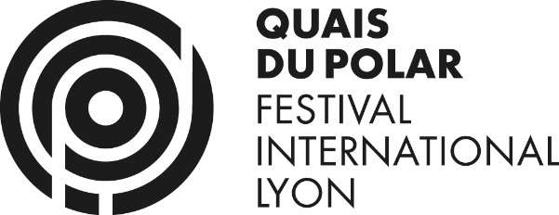 POLAR CONNECTION 2019
REGISTRATION

Submitting my POLAR CONNECTION accreditation means I agree that my contact information (email and phone number) can be given to all POLAR CONNECTION participants.
Accreditation withdrawal will be possible at your arrival at the Palais du Commerce on Friday, March 29th.
POLAR CONNECTION is restricted to book industry and video media professionals. Quais du Polar Team reserves the right to refuse submissions that do not fulfil these criteria and will then proceed in the refund.

Professional informations
Company :
Activity area :
Address :
Zip code :
City :
Country :

Personal informations
First name :
Name :
Function :
Phone :
Mobile phone :
E-mail :

Please send a picture at polarconnection@quaisdupolar.com
Accreditation fee :
55 € preferential rate until March 1st included
70 € HT from March 2nd

Thank you to return this completed form with your check payable to Quais du Polar at QUAIS DU POLAR / Polar Connection - 70 Quai Pierre-Scize, 69005 Lyon.
If necessery, send this form beforehand at polarconnection@quaisdupolar.com asking for a bill that you will pay by check in return. Your registration will be validated upon receipt of the payement.

